BETHKE TECH BADGE PROGRAM - LEVEL 1

Name:
Grade:
Homeroom Teacher:

Directions: Answer the questions and complete the projects.
Use an X inside the []. Like this: [X]

Go to the Bethke Tech Badges website.

----- INTRODUCTION -----

1. Did you watch the Level 1 Introduction video? [] Yes [] No

----- NETBOOKS -----

1. Did you watch the Netbooks video? [] Yes [] No

2. Did you watch the What to Do When Your Netbook Needs Repair video? [] Yes [] No

3. Did you watch the Netbook Rules video? [] Yes [] No

Now it is time for the Netbooks Quiz:

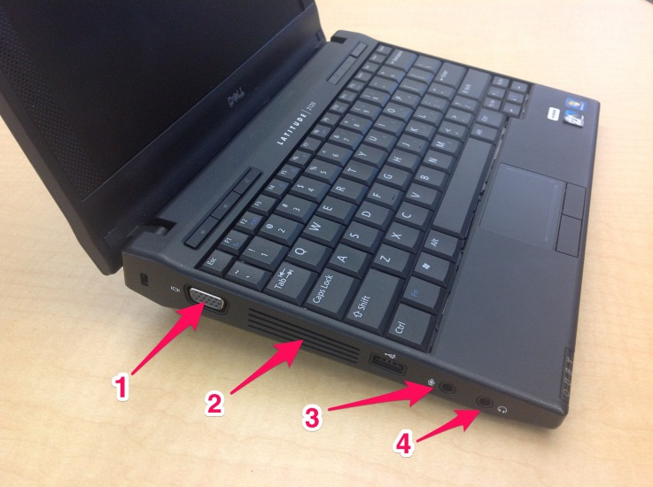
Label the parts shown in the image above:
1.
2.
3.
4.

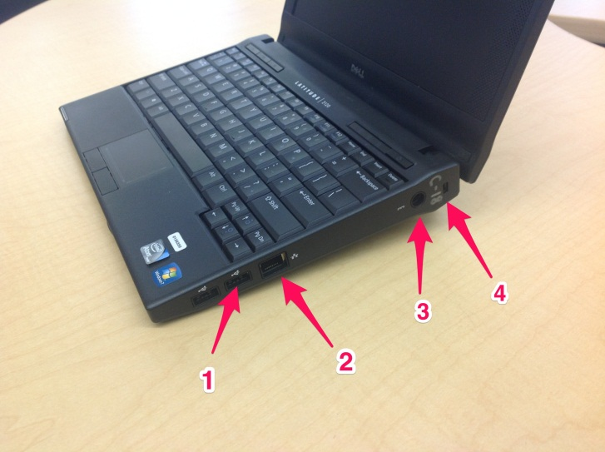
Label the parts shown in the image above:
1.
2.
3.
4.

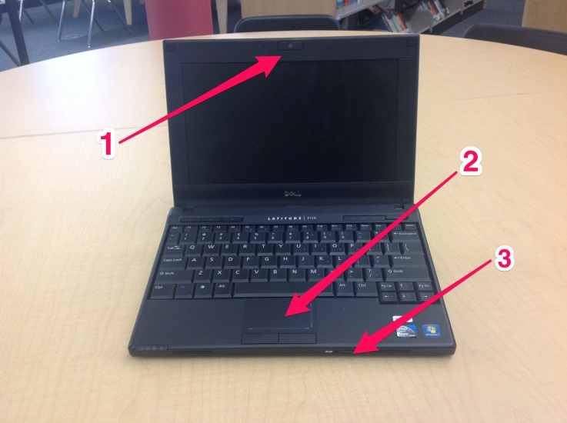
Label the parts shown in the image above:
1.
2.
3.

What are the Netbook Rules?

When you are done, click “File”, then “Save” and show this section to Mr. Mac to be graded.
-----TECH BASICS -----

1. Did you watch the Tech Basics Introduction video? [] Yes []No

3rd Graders, watch all the videos.
4th and 5th Graders, watch the videos about things you forgot. Mr. Mac will quiz you on a skill later.

List the videos that you watched here (add more numbers if needed):
1.
2.
3.

When you have finished reviewing the videos, open MS Word 2010 and make a new document.

Copy and paste the following into the document:

---copy from here---
Dear Mr. Mac,

I have finished reviewing everything in the tech basics section, and I am ready to move on.

Regards,

Timmy Smith (your name here)
Mr. Russel's Class (your teacher here)
---copy to here---

Now save it on the server in the Tech Basics folder following this path:

BETmain/Special Projects/Tech Class/Badges Level 1/Tech Basics

Name the file like this:

techbadges-smith-timmy (but use your real name)

Have Mr. Mac check this file when you are done.

----- ONLINE SAFETY -----

1. Did you watch the Online Safety Introduction video? [] Yes []No

Watch all of the videos for your grade level and then come up with at least five personal rules that you are going to follow while online. Write those rules below:

My Personal Online Rules:
1.
2.
3.
4.
5.

2. Did you read the Bethke Internet Use Policy? [] Yes []No
3. Did you read the Bethke Bring Your Own Device (BYOD) Policy? [] Yes []No

Show this to Mr. Mac when you are done so you can be graded.

----- ONLINE RESEARCH -----

1. Did you watch the Online Research Introduction video? [] Yes []No

Watch the six videos in this lesson and then research the following topics
(find the assignment for your grade):

Grade 3: Libraries for All Organization: Olive Ridley Sea Turtles
In Google search for Olive Ridley Sea Turtles and find the National Geographic website in the results and study that web page.

A: List five facts about this sea turtle you get from the web page:
1.
2.
3.
4.
5.

B: What are the problems facing this sea turtle:

In Google search for La Flor Wildlife Refuge and find the Nicaragua.com website in the results and study that web page.

C: What is the name of the organization that protects the sea turtles?

D: What is a NGO? (use Google to find the answer)

E: How does buying a ticket to the Technology Showcase Event help the sea turtles?

In Google Images download these images (make sure the images are large) to your pictures library on your netbook. Make sure to name each picture appropriately.
1. Adult Olive Ridley Sea Turtle on a beach
2. Baby Olive Ridley Sea Turtle on a beach
3. Baby Olive Ridley Sea Turtle swimming in the ocean
4. Adult Olive Ridley Sea Turtle swimming in the ocean
5. Olive Ridley Sea Turtle laying eggs on the beach
6. People helping the Olive Ridley Sea Turtle
7. Poaching Sea Turtle Eggs
8. La Flor Wildlife Refuge
9. Map of Nicaragua
10. Libraries for All

Grade 4: Libraries for All Organization: Lending Libraries
A: What are the countries that border Nicaragua?

B: What is the literacy rate for Nicaragua?

C: How does that compare to the countries that border Nicaragua and the U.S.?

D: How many Nicaraguans live in poverty?

E: How are poverty and literacy connected?

F: What does the Libraries for All Organization do?

G: Explain how Nicaraguan public libraries are different than U.S. public libraries?

H: Who runs the Libraries for All Organization?

In Google Images download these images (make sure the images are large) to your pictures library on your netbook. Make sure to name each picture appropriately.
1. Map of Nicaragua
2. Nicaraguan child reading a book
3. Nicaraguan family
4. Nicaraguan students in their uniforms
5. Nicaraguan public school
6. San Juan del Sur Biblioteca Movil
7. San Juan del Sur Biblioteca

Grade 5: Libraries for All Organization: Los Quinchos Orphanage
Find the PDF on the Internet called "We Stopped to Look at the Stars" and read it.

Use Google Translate to translate any Spanish words or phrases you don’t understand.

A: Who are the Los Quinchos?

B: Why was Los Quinchos started?

C: What is la raspa?

Find the English version of the Los Quinchos website

D: Who started Los Quichos?

E: What does Los Quinchos do?

Use Google to find the blog about Los Quinchos that is written by Maggie Bishop. Read her entire blog (it is best to start at the bottom and read up, it will make more sense that way).

F: What are five things that you learned that you didn't know before:
1.
2.
3.
4.
5.

Use Google to find the Pulsera Project.

G: What is a pulsera?

F: What is the pulsera project and how does it work?

When you are finished, show this to Mr. Mac to be graded.

----- DIGITAL DATA -----
4th and 5th Grade only

1. Did you watch the Digital Data Introduction video? [] Yes []No

Watch the training videos to understand how to use Google spreadsheets.

Grade 4: Libraries for All Organization: Lending Libraries
Start a new spreadsheet in Google Docs and show the data comparing the literacy rates with the countries that border Nicaragua and also include the U.S. and Mexico. Create a chart and export it as an image to your netbook.

Grade 5: Libraries for All Organization: Los Quinchos Orphanage
Start a new spreadsheet in Google Docs and show the data comparing the poverty rates with the countries that border Nicaragua and also include the U.S. and Mexico. Create a chart and export it as an image to your netbook.

When you’re done, show your image to Mr. Mac

----- DIGITAL WRITING -----

1. Did you watch the Digital Writing Introduction video? [] Yes []No

Watch any of the training videos that you might need to understand how to use a word processor to complete this badge.

Grade 3: Libraries for All Organization: Olive Ridley Sea Turtles
In MS Word 2010 start a new document.
Save this file with the name: seaturtles-smith-timmy on the server following this path:
BETmain/Special Projects/Tech Class/Badges Level 1/Sea Turtle Reports

Copy and paste the following information into your new document...

---copy from here---
(this entire document should be in Times New Roman font, size 12, double line spaced, section headings should be in bold, aligned left)
(the following three lines should be aligned right, and replace with your info)
Timmy Smith
Grade 3
Mrs. Johnson's Class

(center this title and make it bold)
What can I do to help protect the Olive Ridley Sea Turtle?

The Olive Ridley Sea Turtle
(write a paragraph telling a little about this sea turtle using the information you found during your research)

The Problems
(write a paragraph telling about the problems that these sea turtles face)

The Solutions
(write a paragraph telling about what things are being done to solve the problems)

What I Can Do to Help
(write a paragraph explaining how the Libraries for All program is connected to protecting the sea turtles and what you are going to do to help contribute to the Technology Showcase event in May and how this fund-raiser helps the sea turtles)
---copy to here---

Let Mr. Mac know when you are done so he can grade it.

Grade 4: Libraries for All Organization: Lending Libraries
In Google Docs, create a new document with the file name: literacy-smith-timmy

This document needs to be in Times New Roman font, size 12, double line spaced, left hand aligned. Copy and paste the following information into your new document...

---copy from here---
(this entire document should be in Times New Roman font, size 12, double line spaced, section headings should be in bold, aligned left)
(the following three lines should be aligned right, and replace with your info)
Timmy Smith
Grade 4
Mrs. Johnson's Class

(center this title and make it bold)
What can I do to help improve literacy in Nicaragua?

What is the problem?
(write a paragraph explaining the problem of literacy and poverty using the information you found during your research)

Where does the problem come from?
(write a paragraph explaining where you think the problem comes from)

Why do I care?
(write a paragraph explaining why you even care about this problem)

How big is the problem?
(write a paragraph explaining how big the problem is using your spreadsheet and data you collected earlier)

How much can I fix?
(write a paragraph explaining how the Libraries for All program is connected to literacy in Nicaragua and what you are going to do to help contribute to the Technology Showcase event in May and how this fund-raiser helps literacy in Nicaragua)
---copy to here---

When finished export as a word document and save it on the server using this path:
BETmain/Special Projects/Tech Class/Badges Level 1/Literacy Reports

Let Mr. Mac know it is done so it can be graded.

Grade 5: Libraries for All Organization: Los Quinchos Orphanage
In Google Docs, create a new document with the file name: orphans-smith-timmy

This document needs to be in Times New Roman font, size 12, double line spaced, left hand aligned. Copy and paste the following information into your new document...

---copy from here---
(this entire document should be in Times New Roman font, size 12, double line spaced, section headings should be in bold, aligned left)
(the following three lines should be aligned right, and replace with your info)
Timmy Smith
Grade 4
Mrs. Johnson's Class

(center this title and make it bold)
What can I do to help improve the life of the orphans in Nicaragua?

What is the problem?
(write a paragraph explaining the problem of orphans in Nicaragua using the information you found during your research)

Where does the problem come from?
(write a paragraph explaining where you think the problem comes from)

Why do I care?
(write a paragraph explaining why you even care about this problem)

How big is the problem?
(write a paragraph explaining how big the problem is using your spreadsheet and data you collected earlier)

How much can I fix?
(write a paragraph explaining how the Libraries for All program is connected to orphans at Los Quinchos in Nicaragua and what you are going to do to help contribute to the Technology Showcase event in May and how this fund-raiser helps Los Quinchos in Nicaragua)
---copy to here---

When finished export as a word document and save it on the server using this path:
BETmain/Special Projects/Tech Class/Badges Level 1/Orphans Reports

Let Mr. Mac know it is done so it can be graded.

----- DIGITAL PRESENTATION -----

1. Did you watch the Digital Presentation Introduction video? [] Yes []No

Watch any of the training videos that you might need to understand how to use presentation software to complete this badge.

Grade 3: Libraries for All Organization: Olive Ridley Sea Turtles
In MS PowerPoint make a new slide show. Name the slide show seaturtles-smith-timmy and save it on the server following this path:
BETmain/Special Projects/Tech Class/Badges Level 1/Sea Turtles Presentations

Use the information and photos from your research to make this slide show.

Slide 1: Title Slide
Slide 2: Fact 1
Slide 3: Fact 2
Slide 4: Fact 3
Slide 5: Fact 4
Slide 6: Fact 5
Slide 7: Nicaragua Map
Slide 8: La Flor Wildlife Refuge
Slide 9: Fundacion Cocibolca
Slide 10: Buy a Ticket to help save the sea turtles

Present your slide show to the class.

Grade 4: Libraries for All Organization: Lending Libraries
Use the information from your report and the images from your research to make a slide show in Google Docs (minimum of 10 slides)

Name the slide show literacy-smith-timmy and when you are done, export it as a PowerPoint and save it on the server following this path:
BETmain/Special Projects/Tech Class/Badges Level 1/Literacy Presentations

Present your slide show to the class.

Grade 5: Libraries for All Organization: Los Quinchos Orphanage
Use the information from your report and the images from your research to make a slide show in Google Docs (minimum of 10 slides)

Name the slide show literacy-smith-timmy and when you are done, export it as a PowerPoint and save it on the server following this path:
BETmain/Special Projects/Tech Class/Badges Level 1/Orphans Presentations

Present your slide show to the class.

----- EMAIL -----
4th and 5th Grade only

1. Did you watch the Email Introduction video? [] Yes []No

Watch any of the training videos that you might need to understand how to use your email to complete this badge.

RULES FOR EMAILING TEACHERS
1. only email teachers about school work - never jokes or funny photos, etc.
2. always use a subject line that is appropriate
3. always write and email in a formal style
4. be very clear when asking questions

PLEASE NOTE: YOU CANNOT JUST EMAIL ANYONE YOU WANT! FIRST, YOU CAN EMAIL MR. MAC, THEN A CLASSMATE, THEN YOUR TEACHER - THAT'S IT. NO SENDING EMAILS TO FAMILY AND FRIENDS UNTIL YOU HAVE EARNED YOUR BADGE, AND ONLY WITH THE PERMISSION OF YOUR TEACHER.

Skill-Proving Assignment #1:
1. Log on to the district email
2. Start a New Email
3. Address it to Mr. Mac: tmcinern@psdschools.org
4. Subject: Permission Please
5. In the body of the email ask if it is okay for you to send email to other students in your class. (Use proper letter formatting)
6. Send the email
7. Wait for a reply before moving on.
8. When you get the reply back from Mr. Mac start a New Email
9. Address it to someone in your class like 12345@psdschools.org
10. Subject: Knock, Knock Joke
11. In the body of your email ask this person if they want to hear a knock, knock joke.
12. Wait for the reply and then when you get it, send the next part of the joke, and keep repeating until the joke is done.
13. Now you need to send an attachment to your teacher. In MS Word make a new file that just says, "Hello Teacher, this file is to prove to you that I can now send you attachments, so I am ready to turn in my school work via email from now on. Let's save some trees and stop printing pages."
14. Then save this file in your Documents folder. The name should be testattachement-lastname-firstname
15. Start a New Email addressed to your teacher.
16. Subject: Ready to Work
17. Body of the email should say how you are now ready to communicate and turn in work through email. Also explain to your teacher that you will follow the rules as outlined above. Ask your teacher to reply to let you know if they are okay with this.
18. Attach the file you just made to this email.
19. Send it to your teacher.
20. When you have gotten the reply from your teacher, forward that reply to Mr. Mac
21. Done!

----- TYPING -----

Did you watch the Typing Introduction video? [] Yes []No

Show Mr. Mac that you have completed Lesson 29 on Typing Club.

Go to typingtest.com

- you must take the test on TypingTest.com and have a speed greater than 20 words a minute for fifth graders, 13 words a minute for fourth graders and 8 words per minute for third grade.

3rd Grade
In the middle purple Typing Speed Test box, make sure the drop down boxes say English, 1 minute, then you can choose from the third box what topic you want to type about.

4th Grade
In the middle purple Typing Speed Test box, make sure the drop down boxes say English, 2 minutes, then you can choose from the third box what topic you want to type about.

5th Grade
In the middle purple Typing Speed Test box, make sure the drop down boxes say English, 3 minutes, then you can choose from the third box what topic you want to type about.

Show Mr. Mac your score indicating your speed after passing the typing test.

